***Database Systems (Practice Assignment 1)***

Name = Poorab Gangwani

Class = 4B

Roll-Number = CS191092

Instructor = Khubaib Ahmed

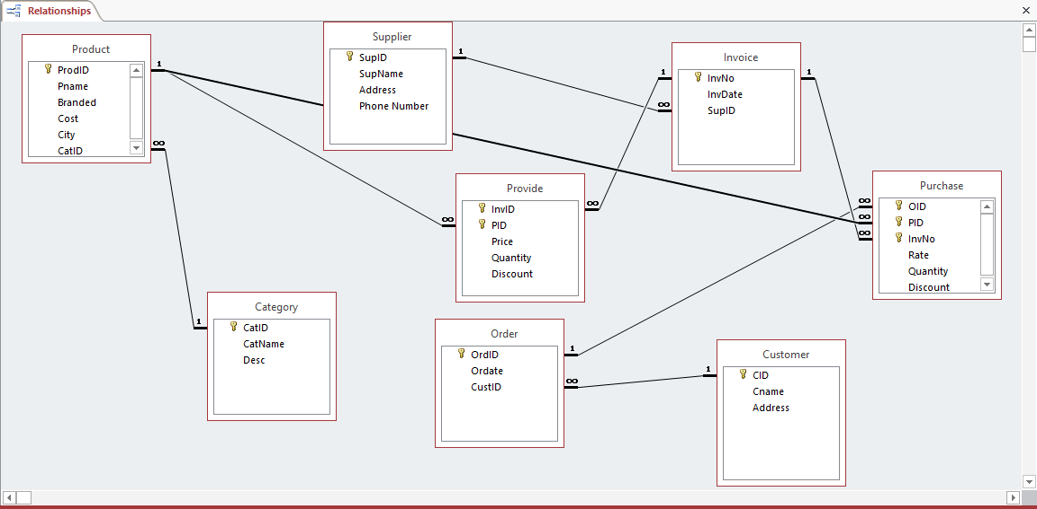

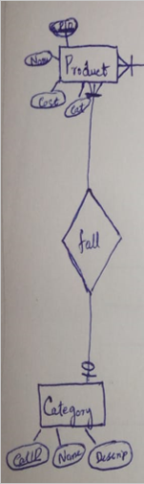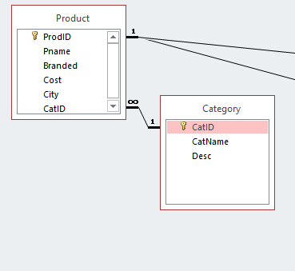

This is Rule 4 and according to it there will be no NULL key in the F.K of CatID in Product Table but duplicate values are allowed in the F.K (CatID).

Example in Access:

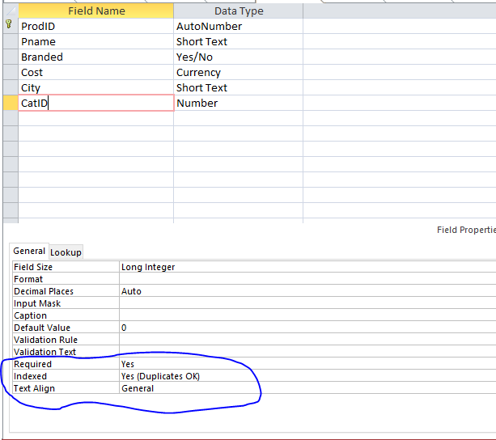

Since A product **must** Have a category so F.K of category is set to **Required = Yes** and since a category can have multiple products so duplicates are set to **Yes (Duplicates OK).**

**Example of Working of Constraint in Category F.K:**

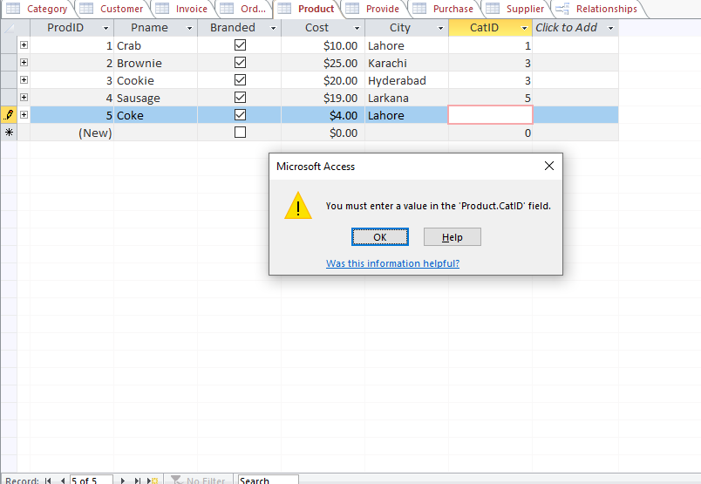

In the above picture , if a block of catID is left unfilled then constraint will appear since all products need a category and duplicate values are allowed.

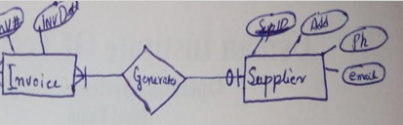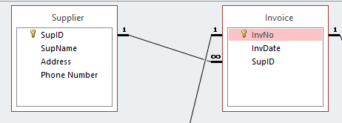Rule 4

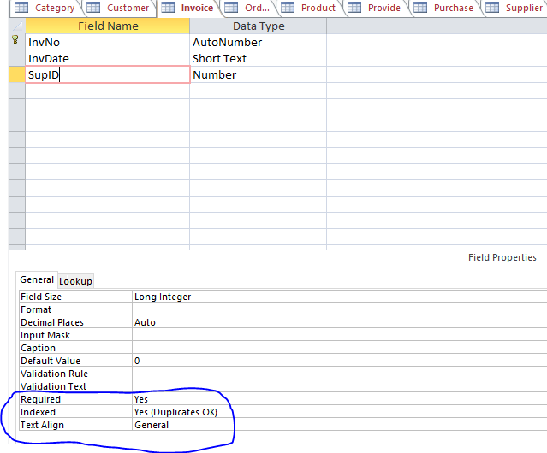

The Same Constraints have been applied in this Entity Relationship Model which were specified previously in Rule 4.

Working of Constraints:

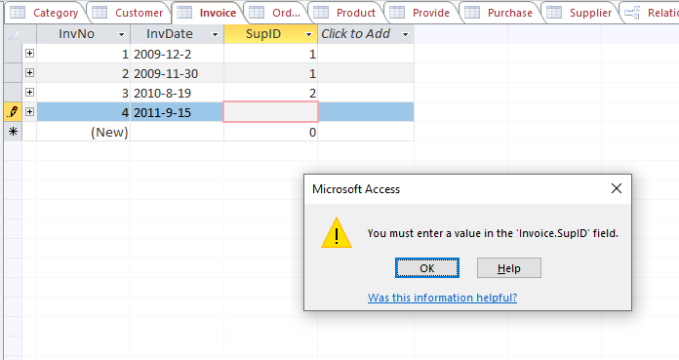

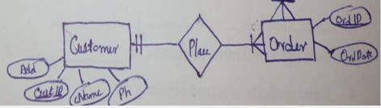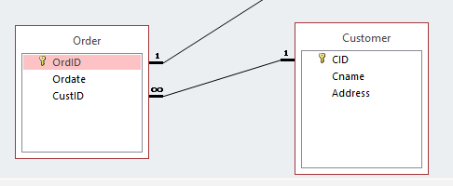Rule 4

In this Case (Customer Places Order),A customer can place multiple Orders and an order can be placed by One Customer. An order **MUST** placed by a customer and

A customer **MUST** place an Order.

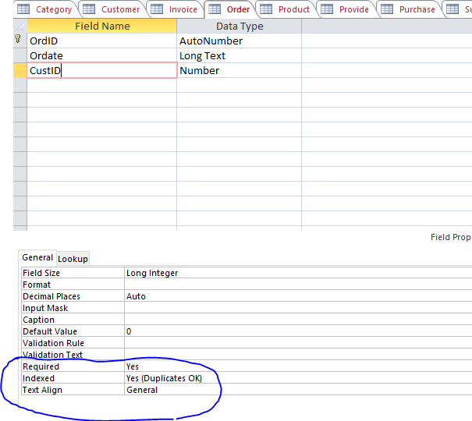

Same Rule 4 Constraints have been Applied

Working of Constraint:

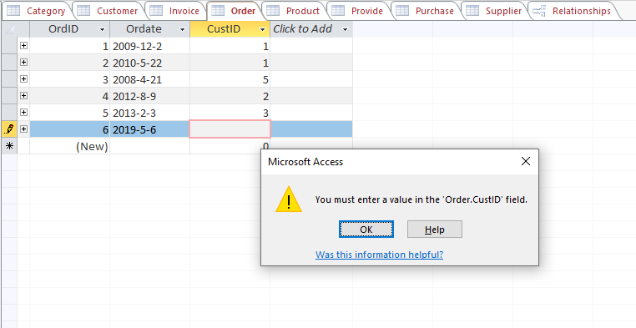

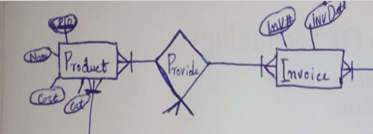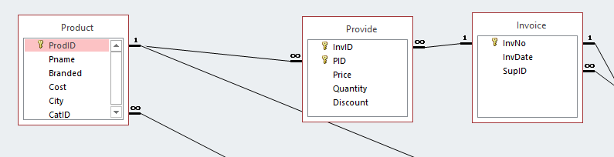

Rule 6 is Applied

In Rule 6 , the F.Ks in Provide table will have **“NOT NULL”**

and Duplicate Values will be allowed.

Constraints:

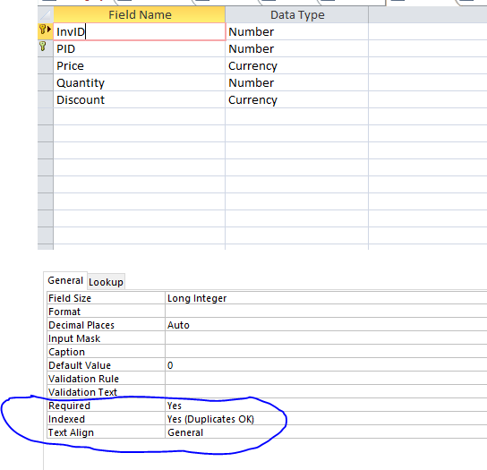

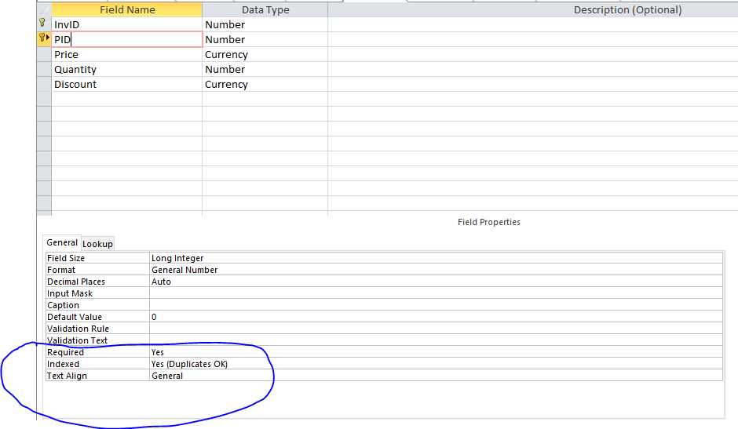

Working of Constraints:

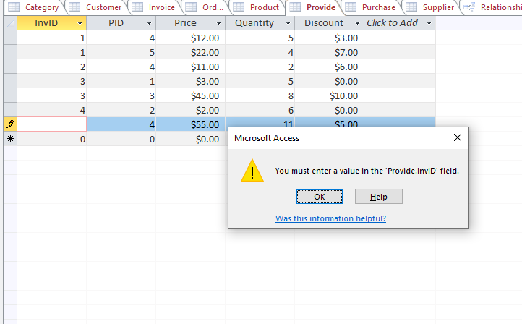

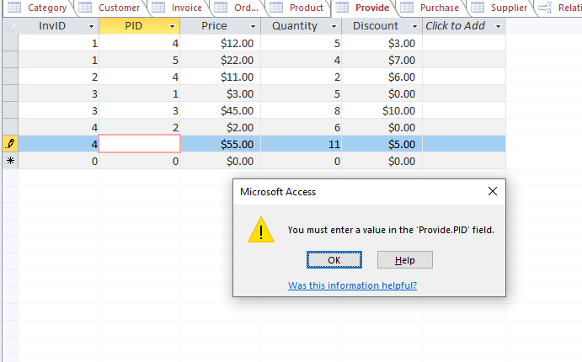

In the Above Pictures , If invID or PID is left Empty then constraint will appear since Neither can be **NULL** and duplicate values can be assigned.

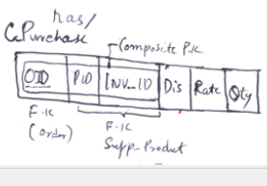Rule 6 has been Applied

Constraints:

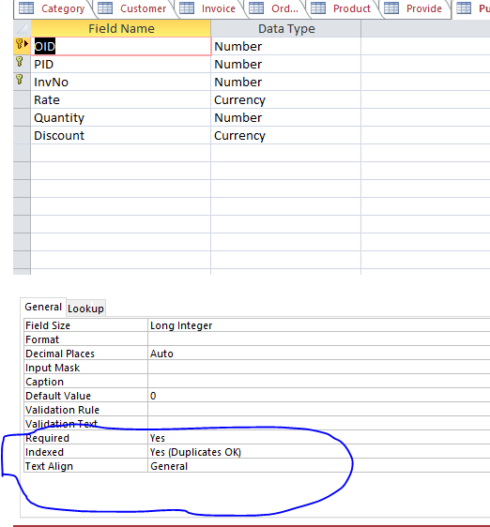

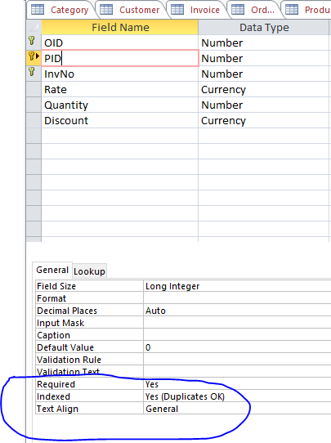

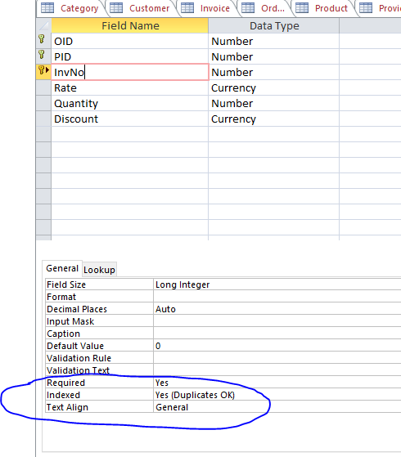

Working of Constraints:

